Azure Question Bank

1. You have an Azure subscription named Subscription1. Subscription1 contains the resource groups in the following table.  
   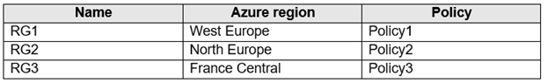  
   RG1 has a web app named WebApp1. WebApp1 is located in West Europe.  
   You move WebApp1 to RG2.  
   What is the effect of the move?

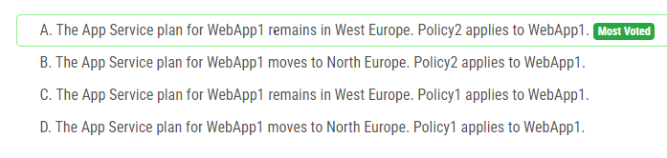

Answer : A

1. You have an Azure subscription.  
   Users access the resources in the subscription from either home or from customer sites. From home, users must establish a point-to-site VPN to access the Azure resources. The users on the customer sites access the Azure resources by using site-to-site VPNs.  
   You have a line-of-business-app named App1 that runs on several Azure virtual machine. The virtual machines run Windows Server 2016.  
   You need to ensure that the connections to App1 are spread across all the virtual machines.  
   What are two possible Azure services that you can use? Each correct answer presents a complete solution.  
   NOTE: Each correct selection is worth one point.

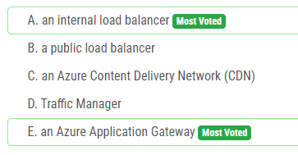

Answer : AE

1. You have an Azure subscription.  
   You have 100 Azure virtual machines.  
   You need to quickly identify underutilized virtual machines that can have their service tier changed to a less expensive offering.  
   Which blade should you use?

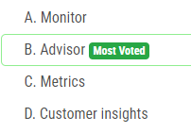

Answer : B

1. You have an Azure Active Directory (Azure AD) tenant named contoso.onmicrosoft.com.  
   The User administrator role is assigned to a user named Admin1.  
   An external partner has a Microsoft account that uses the user1@outlook.com sign in.  
   Admin1 attempts to invite the external partner to sign in to the Azure AD tenant and receives the following error message: `Unable to invite user user1@outlook.com `" Generic authorization exception.`  
   You need to ensure that Admin1 can invite the external partner to sign in to the Azure AD tenant.  
   What should you do?

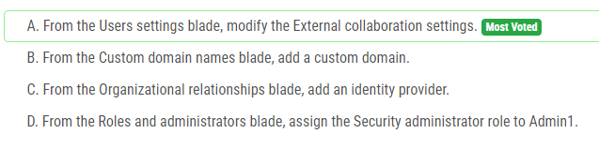

Answer : A

1. You have an Azure subscription linked to an Azure Active Directory tenant. The tenant includes a user account named User1.  
   You need to ensure that User1 can assign a policy to the tenant root management group.  
   What should you do?

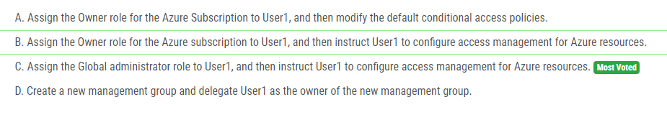

Answer : B

1. You have a hybrid deployment of Azure Active Directory (Azure AD) that contains the users shown in the following table.  
   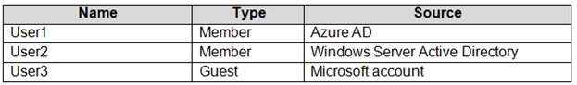  
   You need to modify the JobTitle and UsageLocation attributes for the users.  
   For which users can you modify the attributes from Azure AD? To answer, select the appropriate options in the answer area.  
   NOTE: Each correct selection is worth one point.

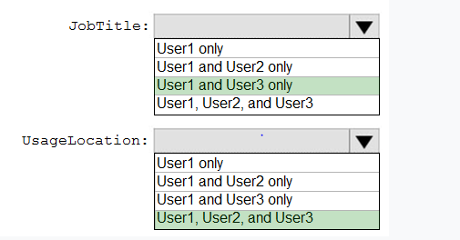

Answer : CD

1. This question is part of a series of questions that present the same scenario. Each question in the series contains a unique solution that might meet the stated goals. Some question sets might have more than one correct solution, while others might not have a correct solution.  
   After you answer a question in this section, you will NOT be able to return to it. As a result, these questions will not appear in the review screen.  
   You need to ensure that an Azure Active Directory (Azure AD) user named Admin1 is assigned the required role to enable Traffic Analytics for an Azure subscription.

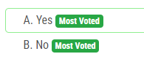

Answer : B [No] [Only Owner,Contributor and Network Contributor]

1. You have an Azure subscription that contains a user named User1.  
   You need to ensure that User1 can deploy virtual machines and manage virtual networks. The solution must use the principle of least privilege.  
   Which role-based access control (RBAC) role should you assign to User1?

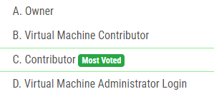

1. You have an Azure subscription named Subscription1 that contains an Azure virtual machine named VM1. VM1 is in a resource group named RG1.  
   VM1 runs services that will be used to deploy resources to RG1.  
   You need to ensure that a service running on VM1 can manage the resources in RG1 by using the identity of VM1.  
   What should you do first?

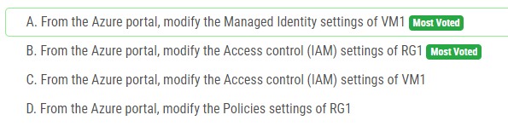

Answer : A

1. You have an Azure subscription that contains a resource group named TestRG.  
   You use TestRG to validate an Azure deployment.  
   TestRG contains the following resources:  
   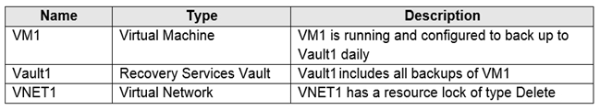  
   You need to delete TestRG.  
   What should you do first?

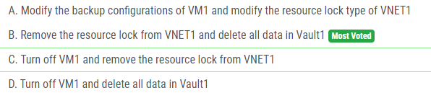

Answer : B

1. You have an Azure DNS zone named adatum.com.  
   You need to delegate a subdomain named research.adatum.com to a different DNS server in Azure.  
   What should you do?

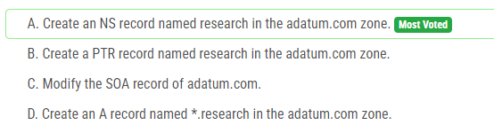

Answer : A

1. You have an Azure subscription named Subscription1 that contains a virtual network named VNet1. VNet1 is in a resource group named RG1.  
     
   Subscription1 has a user named User1. User1 has the following roles:  
     
   • Reader  
   • Security Admin  
   • Security Reader  
     
   You need to ensure that User1 can assign the Reader role for VNet1 to other users.  
     
   What should you do?

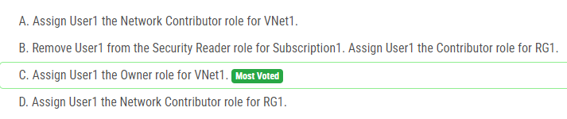

Answer : C

1. Your on-premises network contains a VPN gateway.  
     
   You have an Azure subscription that contains the resources shown in the following table.  
     
   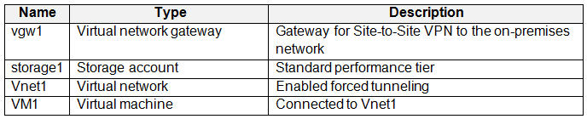  
     
   You need to ensure that all the traffic from VM1 to storage1 travels across the Microsoft backbone network.  
     
   What should you configure?

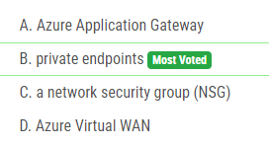

Answer : B

1. You have an Azure subscription that contains a user named User1 and the resources shown in the following table.  
     
   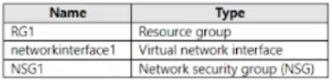  
     
   NSG1 is associated to networkinterface1.  
     
   User1 has role assignments for NSG1 as shown in the following table.  
     
   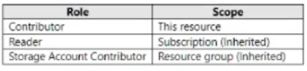  
     
   For each of the following statements, select Yes if the statement is true. Otherwise, select No.  
     
   NOTE: Each correct selection is worth one point.

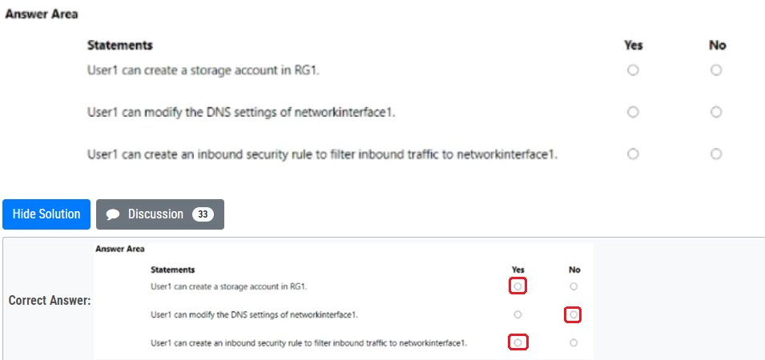

Answer: Yes No Yes

15)

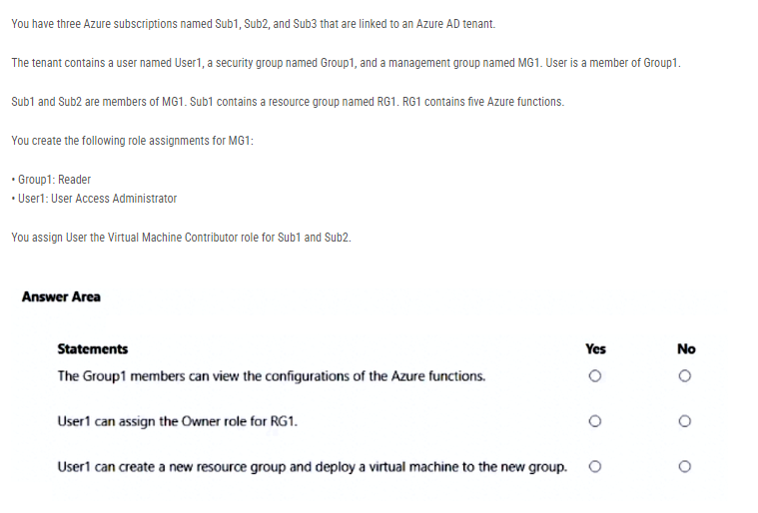

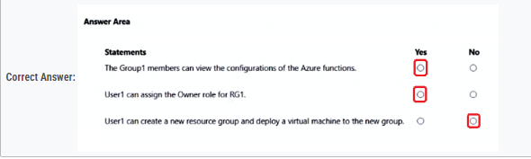

Answer : YYN

16) You have an Azure subscription that contains the resources shown in the following table.  
  
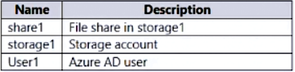  
  
You need to assign User1 the Storage File Data SMB Share Contributor role for share1.  
  
What should you do first?

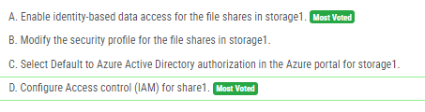

Answer : A

17) You have an Azure subscription named Subscription1 that contains a virtual network named VNet1. VNet1 is in a resource group named RG1.  
  
Subscription1 has a user named User1. User1 has the following roles:  
  
• Reader  
• Security Admin  
• Security Reader  
  
You need to ensure that User1 can assign the Reader role for VNet1 to other users.  
  
What should you do?

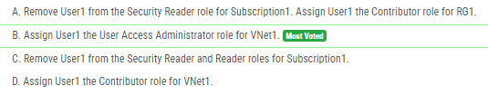

Answer: B

18) You have an Azure AD tenant named adatum.com that contains the groups shown in the following table.  
  
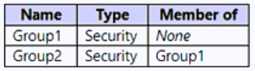  
  
Adatum.com contains the users shown in the following table.  
  
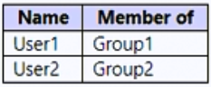  
  
You assign an Azure Active Directory Premium P2 license to Group1 as shown in the following exhibit.  
  
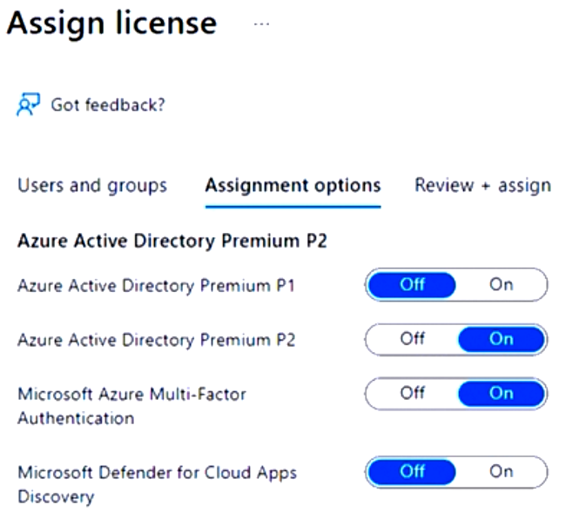  
  
Group2 is NOT directly assigned a license.  
  
For each of the following statements, select Yes if the statement is true. Otherwise, select No.  
  
NOTE: Each correct selection is worth one point

Answer : 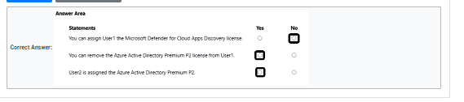

19) You have a hybrid deployment of Azure Active Directory (Azure AD) that contains the users shown in the following table.  
  
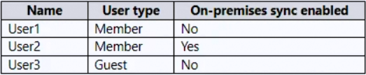  
  
You need to modify the JobTitle and UsageLocation attributes for the users.  
  
For which users can you modify the attributes from Azure AD? To answer, select the appropriate options in the answer area.  
  
NOTE: Each correct selection is worth one point.

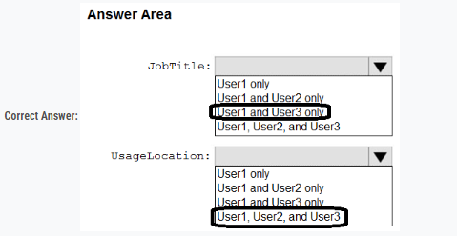

Answer : CD

20) Note: This question is part of a series of questions that present the same scenario. Each question in the series contains a unique solution that might meet the stated goals. Some question sets might have more than one correct solution, while others might not have a correct solution.  
  
After you answer a question in this section, you will NOT be able to return to it. As a result, these questions will not appear in the review screen.  
  
You have an Azure Active Directory (Azure AD) tenant named contoso.com.  
  
You have a CSV file that contains the names and email addresses of 500 external users.  
  
You need to create a guest user account in contoso.com for each of the 500 external users.  
  
Solution: You create a PowerShell script that runs the New-MgInvitation cmdlet for each external user.  
  
Does this meet the goal?

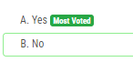

Answer : A

21) You have an Azure Storage account named storage1 that uses Azure Blob storage and Azure File storage.  
  
You need to use AzCopy to copy data to the blob storage and file storage in storage1.  
  
Which authentication method should you use for each type of storage? To answer, select the appropriate options in the answer area.  
  
NOTE: Each correct selection is worth one point.

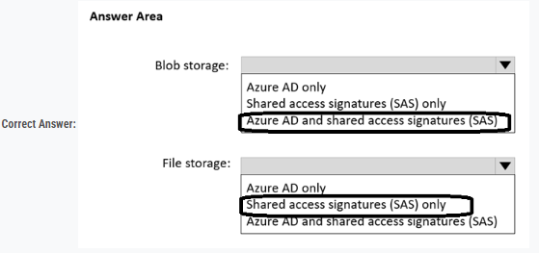

Answer : CA

22) You have an Azure subscription that contains the resources shown in the following table.  
  
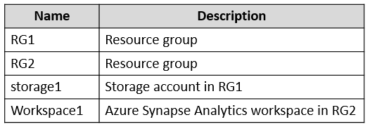  
  
You need to assign Workspace1 a role to allow read, write, and delete operations for the data stored in the containers of storage1.  
  
Which role should you assign?

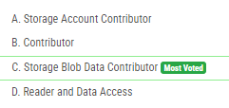

Answer : C

23) You have an Azure AD tenant that contains the groups shown in the following table.  
  
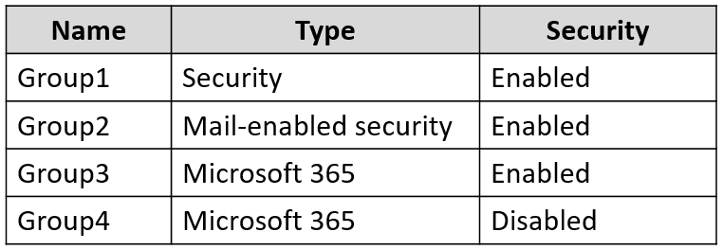  
  
You purchase Azure Active Directory Premium P2 licenses.  
  
To which groups can you assign a license?

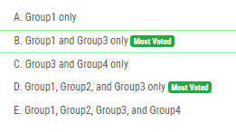

Asnwer: B

24) You have an Azure AD tenant.  
  
You need to create a Microsoft 365 group that contains only members of a marketing department in France.  
  
How should you complete the dynamic membership rule? To answer, select the appropriate options in the answer area.  
  
NOTE: Each correct answer is worth one point.

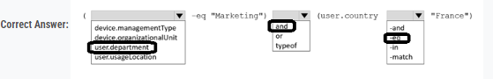

25) You have an Azure AD tenant.  
  
You need to modify the Default user role permissions settings for the tenant. The solution must meet the following requirements:  
  
• Standard users must be prevented from creating new service principals.  
• Standard users must only be able to use PowerShell or Microsoft Graph to manage their own Azure resources.  
  
Which two settings should you modify? To answer, select the appropriate settings in the answer area.  
  
NOTE: Each correct answer is worth one point.

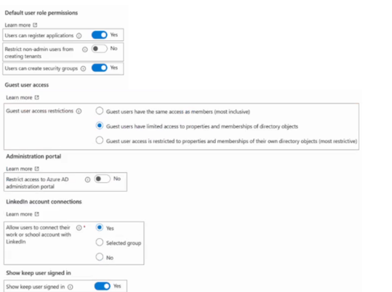

26) HOTSPOT  
-  
  
You have an Azure subscription named Sub1 that contains the blob containers shown in the following table.  
  
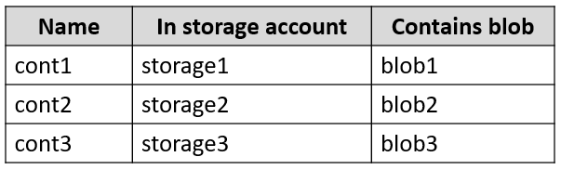  
  
Sub1 contains two users named User1 and User2. Both users are assigned the Reader role at the Sub1 scope.  
  
You have a condition named Condition1 as shown in the following exhibit.  
  
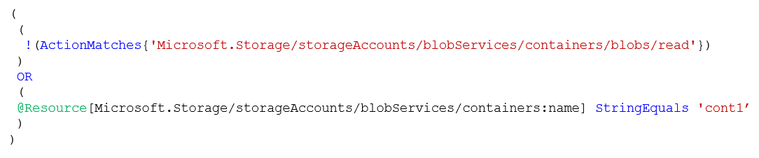  
  
You have a condition named Condition2 as shown in the following exhibit.  
  
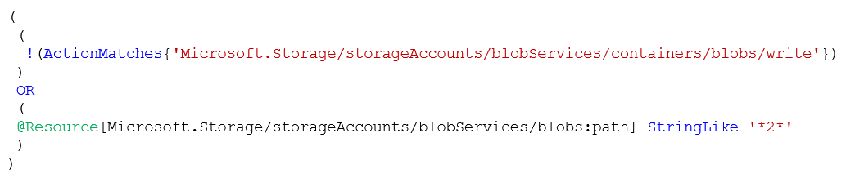  
  
You assign roles to User1 and User2 as shown in the following table.  
  
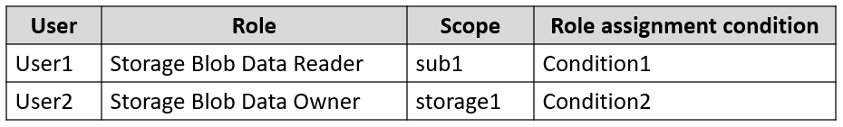  
  
For each of the following statements, select Yes if the statement is true. Otherwise, select No.

Answer : NNY

27) You have an Azure subscription named Sub1 that contains the resources shown in the following table.  
  
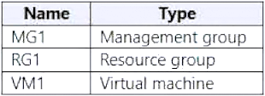  
  
You create a user named Admin1.  
  
To what can you add Admin1 as a co-administrator?

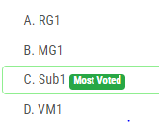

Answer : C

28) You have a Microsoft Entra tenant that contains the groups shown in the following table.  
  
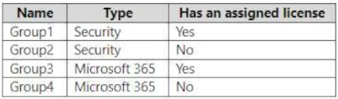  
  
The tenant contains the users shown in the following table.  
  
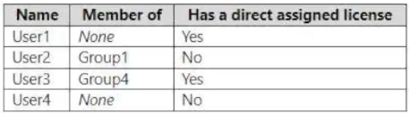  
  
Which users and groups can you delete? To answer, select the appropriate options in the answer area.

Answer : All Users and Group2 and Group 4.

29) You have an Azure subscription named Subscription1 that contains the storage accounts shown in the following table:  
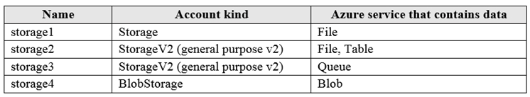  
You plan to use the Azure Import/Export service to export data from Subscription1.  
You need to identify which storage account can be used to export the data.  
What should you identify?

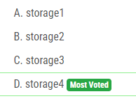

Answer : D

30) You have Azure Storage accounts as shown in the following exhibit.  
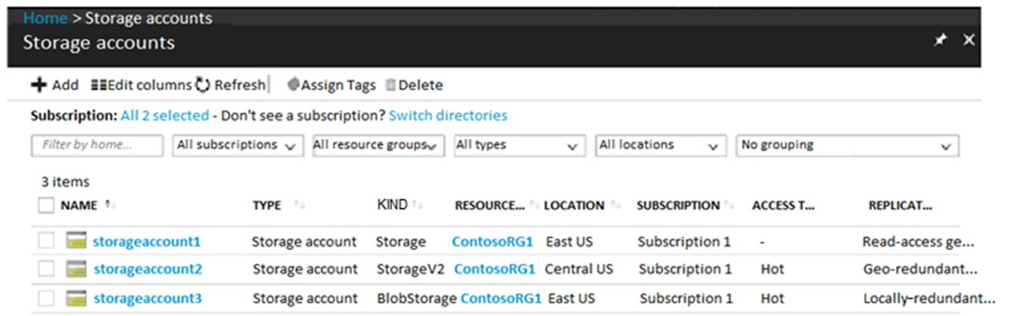  
Use the drop-down menus to select the answer choice that completes each statement based on the information presented in the graphic.  
NOTE: Each correct selection is worth one point.  
Hot Area:  
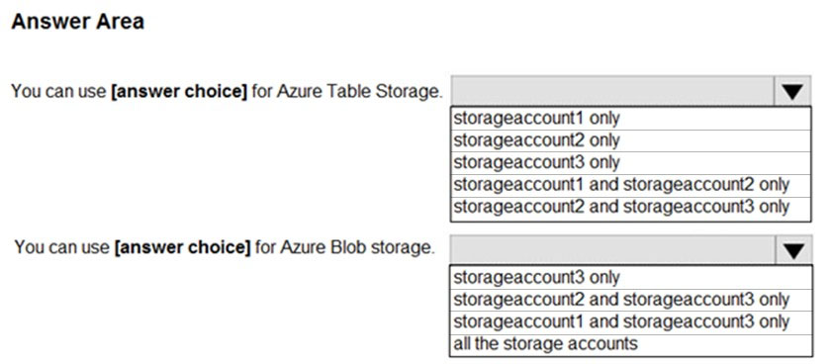

*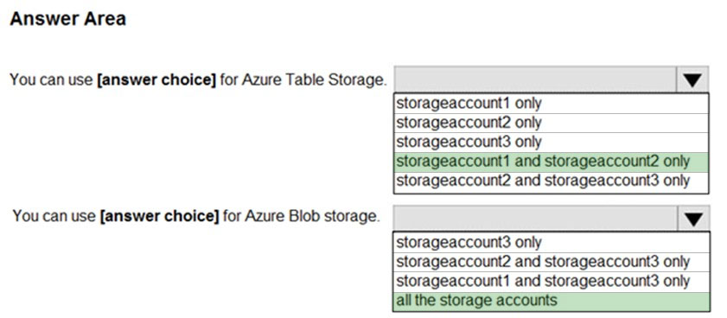*

31) You have Azure subscription that includes data in following locations:  
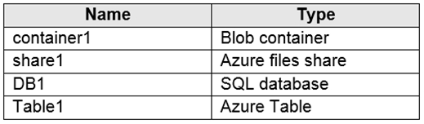  
You plan to export data by using Azure import/export job named Export1.  
You need to identify the data that can be exported by using Export1.  
Which data should you identify?

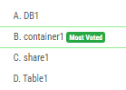

32) You have an Azure Storage account named storage1.  
You have an Azure App Service app named App1 and an app named App2 that runs in an Azure container instance. Each app uses a managed identity.  
You need to ensure that App1 and App2 can read blobs from storage1. The solution must meet the following requirements:  
✑ Minimize the number of secrets used.  
✑ Ensure that App2 can only read from storage1 for the next 30 days.  
What should you configure in storage1 for each app? To answer, select the appropriate options in the answer area.  
NOTE: Each correct selection is worth one point.  
Hot Area:

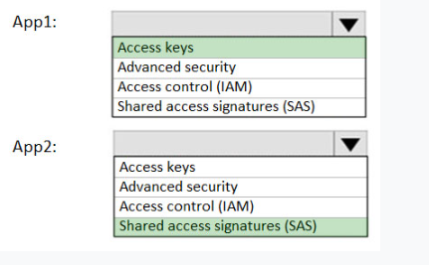

33) You need to create an Azure Storage account that meets the following requirements:  
✑ Minimizes costs  
✑ Supports hot, cool, and archive blob tiers  
✑ Provides fault tolerance if a disaster affects the Azure region where the account resides  
How should you complete the command? To answer, select the appropriate options in the answer area.  
NOTE: Each correct selection is worth one point.

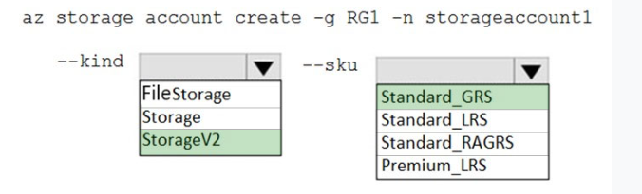

33) You have an Azure subscription that contains the resources in the following table.  
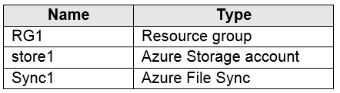  
Store1 contains a file share named data. Data contains 5,000 files.  
You need to synchronize the files in the file share named data to an on-premises server named Server1.  
Which three actions should you perform? Each correct answer presents part of the solution.  
NOTE: Each correct selection is worth one point.

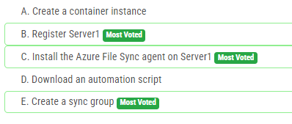

34) You have an Azure subscription that contains a storage account.  
You have an on-premises server named Server1 that runs Windows Server 2016. Server1 has 2 TB of data.  
You need to transfer the data to the storage account by using the Azure Import/Export service.  
In which order should you perform the actions? To answer, move all actions from the list of actions to the answer area and arrange them in the correct order.  
NOTE: More than one order of answer choices is correct. You will receive credit for any of the correct orders you select.

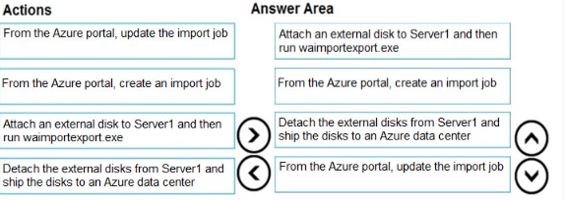

35) You have Azure subscription that includes following Azure file shares:  
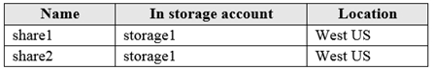  
You have the following on-premises servers:  
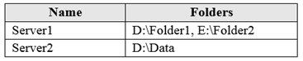  
You create a Storage Sync Service named Sync1 and an Azure File Sync group named Group1. Group1 uses share1 as a cloud endpoint.  
You register Server1 and Server2 in Sync1. You add D:\Folder1 on Server1 as a server endpoint of Group1.  
For each of the following statements, select Yes if the statement is true. Otherwise, select No.  
NOTE: Each correct selection is worth one point.  
Hot Area:

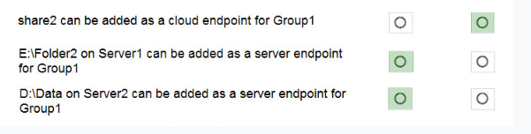

35) You have an Azure subscription named Subscription1.  
You create an Azure Storage account named contosostorage, and then you create a file share named data.  
Which UNC path should you include in a script that references files from the data file share? To answer, drag the appropriate values to the correct targets. Each value may be used once, more than once or not at all. You may need to drag the split bar between panes or scroll to view content.  
NOTE: Each correct selection is worth one point.

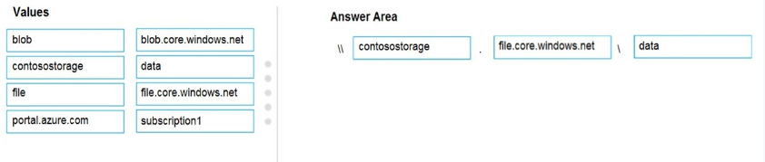

36) You have an Azure subscription that contains an Azure Storage account.  
You plan to copy an on-premises virtual machine image to a container named vmimages.  
You need to create the container for the planned image.  
Which command should you run? To answer, select the appropriate options in the answer area.  
NOTE: Each correct selection is worth one point.

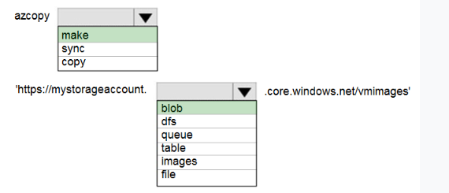

37) You have an Azure File sync group that has the endpoints shown in the following table.  
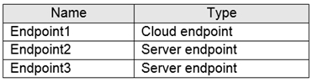  
Cloud tiering is enabled for Endpoint3.  
You add a file named File1 to Endpoint1 and a file named File2 to Endpoint2.  
On which endpoints will File1 and File2 be available within 24 hours of adding the files? To answer, select the appropriate options in the answer area.  
NOTE: Each correct selection is worth one point.  
Hot Area:

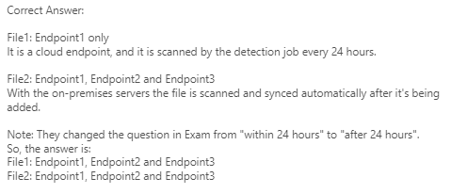

38) HOTSPOT -  
You have several Azure virtual machines on a virtual network named VNet1.  
You configure an Azure Storage account as shown in the following exhibit.  
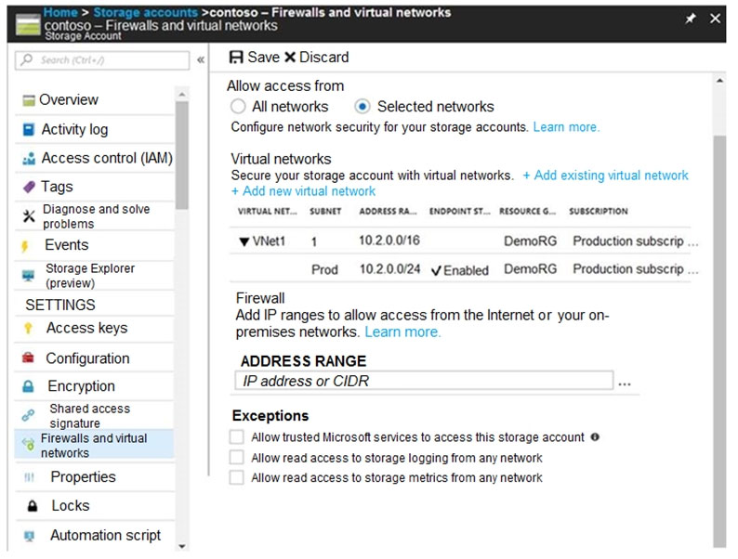  
Use the drop-down menus to select the answer choice that completes each statement based on the information presented in the graphic.  
NOTE: Each correct selection is worth one point.  
Hot Area:

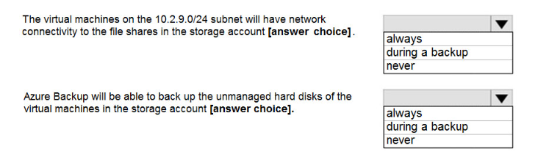

39) HOTSPOT -  
You have a sync group named Sync1 that has a cloud endpoint. The cloud endpoint includes a file named File1.txt.  
Your on-premises network contains servers that run Windows Server 2016. The servers are configured as shown in the following table.  
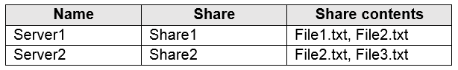  
You add Share1 as an endpoint for Sync1. One hour later, you add Share2 as an endpoint for Sync1.  
For each of the following statements, select Yes if the statement is true. Otherwise, select No.  
NOTE: Each correct selection is worth one point.  
Hot Area:  
  
  
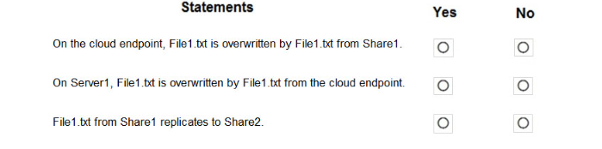

Answer : N N Y

40) You have an Azure subscription that contains the storage accounts shown in the following table.  
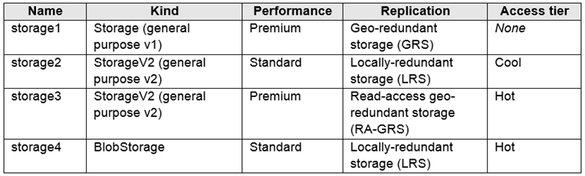  
You need to identify which storage account can be converted to zone-redundant storage (ZRS) replication by requesting a live migration from Azure support.  
What should you identify?

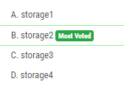

Answer : B

41) You have an Azure subscription that contains a storage account named account1.  
You plan to upload the disk files of a virtual machine to account1 from your on-premises network. The on-premises network uses a public IP address space of  
131.107.1.0/24.  
You plan to use the disk files to provision an Azure virtual machine named VM1. VM1 will be attached to a virtual network named VNet1. VNet1 uses an IP address space of 192.168.0.0/24.  
You need to configure account1 to meet the following requirements:  
✑ Ensure that you can upload the disk files to account1.  
✑ Ensure that you can attach the disks to VM1.  
✑ Prevent all other access to account1.  
Which two actions should you perform? Each correct answer presents part of the solution.  
NOTE: Each correct selection is worth one point.

42) You have an Azure subscription that contains a storage account named account1.  
You plan to upload the disk files of a virtual machine to account1 from your on-premises network. The on-premises network uses a public IP address space of  
131.107.1.0/24.  
You plan to use the disk files to provision an Azure virtual machine named VM1. VM1 will be attached to a virtual network named VNet1. VNet1 uses an IP address space of 192.168.0.0/24.  
You need to configure account1 to meet the following requirements:  
✑ Ensure that you can upload the disk files to account1.  
✑ Ensure that you can attach the disks to VM1.  
✑ Prevent all other access to account1.  
Which two actions should you perform? Each correct answer presents part of the solution.  
NOTE: Each correct selection is worth one point.

Answer : 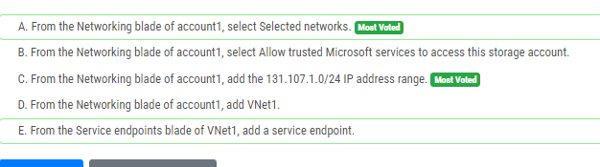

Answer : AC

43) DRAG DROP -  
You have an on-premises file server named Server1 that runs Windows Server 2016.  
You have an Azure subscription that contains an Azure file share.  
You deploy an Azure File Sync Storage Sync Service, and you create a sync group.  
You need to synchronize files from Server1 to Azure.  
Which three actions should you perform in sequence? To answer, move the appropriate actions from the list of actions to the answer area and arrange them in the correct order.  
Select and Place:

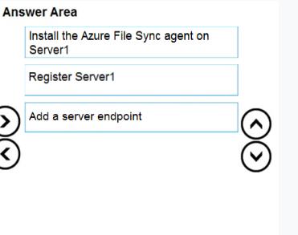

44) HOTSPOT -  
You plan to create an Azure Storage account in the Azure region of East US 2.  
You need to create a storage account that meets the following requirements:  
✑ Replicates synchronously.  
✑ Remains available if a single data center in the region fails.  
How should you configure the storage account? To answer, select the appropriate options in the answer area.  
NOTE: Each correct selection is worth one point.  
Hot Area:

Answer : 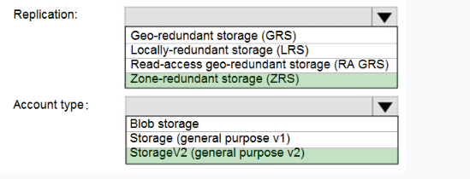

45) You plan to use the Azure Import/Export service to copy files to a storage account.  
Which two files should you create before you prepare the drives for the import job? Each correct answer presents part of the solution.  
NOTE: Each correct selection is worth one point.

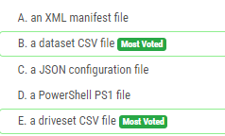

46) You have an Azure subscription that contains an Azure file share.  
You have an on-premises server named Server1 that runs Windows Server 2016.  
You plan to set up Azure File Sync between Server1 and the Azure file share.  
You need to prepare the subscription for the planned Azure File Sync.  
Which two actions should you perform in the Azure subscription? To answer, drag the appropriate actions to the correct targets. Each action may be used once, more than once, or not at all. You may need to drag the split bar between panes or scroll to view content.  
NOTE: Each correct selection is worth one point.

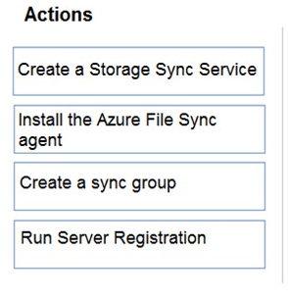

Answer: 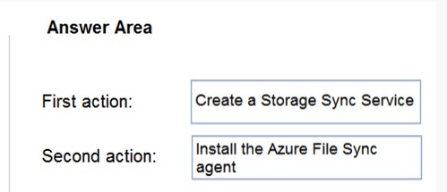

47) You have an Azure subscription named Subscription1 that contains the resources shown in the following table:  
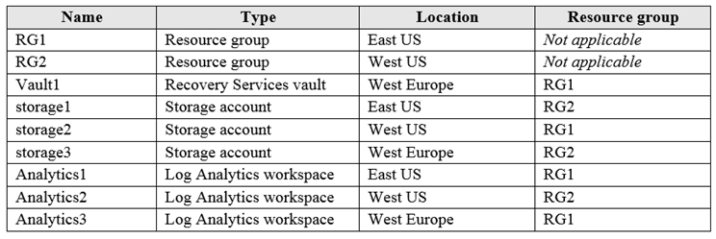  
You plan to configure Azure Backup reports for Vault1.  
You are configuring the Diagnostics settings for the AzureBackupReports log.  
Which storage accounts and which Log Analytics workspaces can you use for the Azure Backup reports of Vault1? To answer, select the appropriate options in the answer area.  
NOTE: Each correct selection is worth one point.  
Hot Area:

Answer: 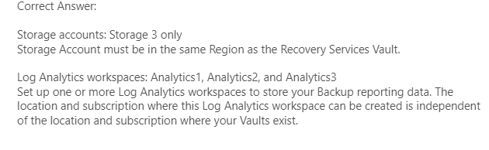

48)

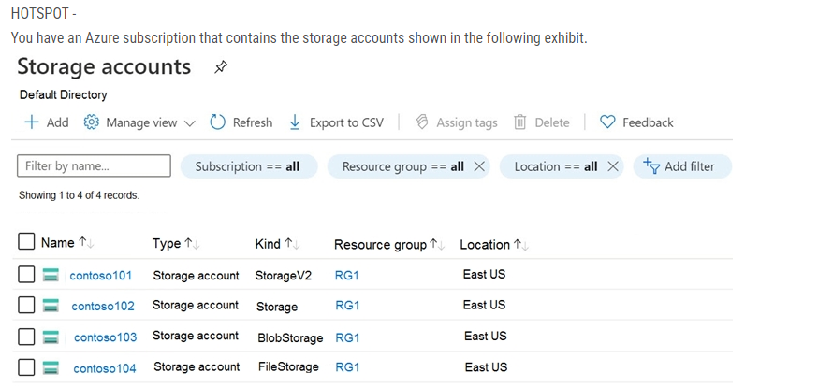

Answer :

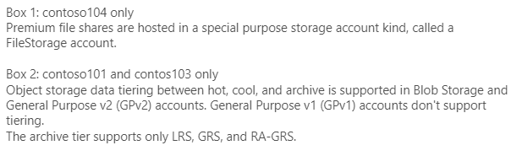

49)

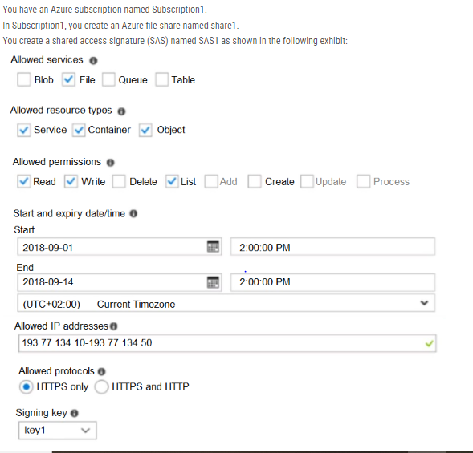

Answer : 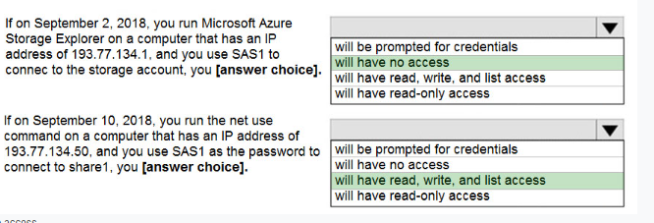

50) You have two Azure virtual machines named VM1 and VM2. You have two Recovery Services vaults named RSV1 and RSV2.  
VM2 is backed up to RSV1.  
You need to back up VM2 to RSV2.  
What should you do first?

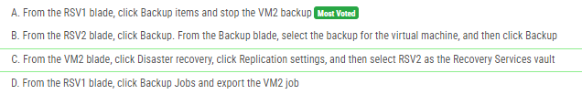

Answer : A

51) You have a general-purpose v1 Azure Storage account named storage1 that uses locally-redundant storage (LRS).  
You need to ensure that the data in the storage account is protected if a zone fails. The solution must minimize costs and administrative effort.  
What should you do first?

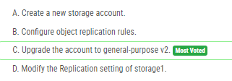

52) You have an Azure subscription that contains the storage accounts shown in the following table.  
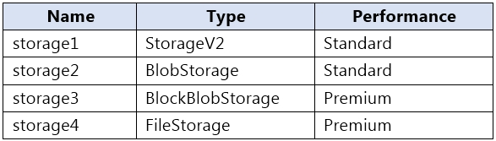  
You plan to manage the data stored in the accounts by using lifecycle management rules.  
To which storage accounts can you apply lifecycle management rules?

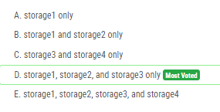

53) You create an Azure Storage account named contosostorage.  
You plan to create a file share named data.  
Users need to map a drive to the data file share from home computers that run Windows 10.  
Which outbound port should you open between the home computers and the data file share?

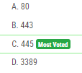

54)